Angle grinder
AG950A AG950B
GB

GB

Read this operators guide carefully, before using the machine. Ensure that you know how the machine works, and how it should be operated. Maintain the machine in accordance with the instructions, and make certain that the machine functions correctly. Keep this operator’s guide and other enclosed documentation with the machine.

TECHNICAL SPECIFICATIONS
Model | AG950A | AG950B
Rated Voltage | 220-240V ~ 50/60Hz | 220-240V ~ 50/60Hz
Power | 950W | 950W
No load speed | 11000/min | 11000/min
Disc size | 100X16mm | 125X22.2mm
Net weight | 1.6kg | 1.6kg

Over view

AG950A angle grinder AG950B angle grinder
- Spindle lock button
- Disc
- Power switch
- Motor housing
- Rear Motor housing
- Guard

General Safety Instructions for Electric Tools
This device is exclusively for private use! It is not fit for commercial use!
WARNING! Read all instructions. Failure to follow all instructions listed below may result in electric shock, fire and/or serious injury :
SAVE THESE INSTRUCTIONS
1)Work area
• Keep work area clean and well lit. Cluttered and dark areas invite accidents
• Do not operate machines in explosive atmospheres, such as in the presence of flammable liquids, gases or dust. Machines create sparks which may ignite the dust or fumes.
• Keep children and bystanders away while operating a machine. Distractions can cause you to lose control.
2)Electrical safety
• Machine plugs must match the outlet. Never modify the plug in any way. Do not use any adapter plugs with earthed (grounded) machines. Unmodified plugs and matching outlets will reduce risk of electric shock.
• Avoid body contact with earthed or grounded surfaces such as pipes, radiators, ranges and refrigerators. There is an increased risk of electric shock if your body is earthed or grounded.
• Do not expose machines to rain or wet conditions. Water entering a machine will increase the risk of electric shock.
• Do not abuse the cord. Never use the cord for carrying, pulling or unplugging the machine. Keep cord away from heat, oil, sharp edges or moving parts. Damaged or entangled cords increase the risk of electric shock.
• When operating a machine outdoors, use an extension cord suitable for outdoor use. Use of a cord suitable for outdoor use reduces the risk of electric shock.

3)Personal safety
• Stay alert, Watch what you are doing and use common sense when operating a machine. Do not use a machine while you are tired or under the influence of drugs, alcohol or medication. A moment of inattention while operating machines may result in serious personal injury.
• Use safety equipment. Always wear eye protection. Safety equipment such as dust mark, non-skid safety shoes, hard hat, or hearing protection used for appropriate conditions will reduce personal injuries.
•Avoid accidental starting. Ensure the switch is in the off position before plugging in. Carrying machines with your finger on the switch or plugging in machines that have the switch on invites accidents.
•Remove any adjusting key or wrench before turning the machine on. A wrench or a key left attached to a rotating part of the machine may result in personal injury.
•Do not overreach. Keep proper footing and balance at all times. This enables better control of the machine in unexpected situations.
• Dress properly. Do not wear loose clothing or jewellery. Keep your hair, clothing and gloves away from moving parts. Loose clothes, jewellery or long hair can be caught in moving parts.
• If devices are provided for the connection of dust extraction and collection facilities, ensure these are connected and properly used. Use of these devices can reduce dust related hazards.

4)Machine use and care
• Do not force the machine. Use the correct machine for your application. The correct machine will do the job better and safer at the rate for which it was designed.
•Do not use the machine if the switch does not turn it on and off. Any machine that can not be controlled with the switch is dangerous and must be repaired.
•Disconnect the plug from the power source before making any adjustments, changing accessories, or storing machines. Such preventive safety measures reduce the risk of starting the machine accidentally.
• Store idle machines out of the reach children and do not allow persons unfamiliar with the machine or these instructions to operate the machine. Machines are dangerous in the hands of untrained users.
• Maintain machines. Check for misalignment or binding of moving parts, breakage of parts and any other condition that may affect the machines operation. If damaged, have the machine repaired before use. Many accidents are caused by poorly maintained machines.
•Keep cutting tools sharp and clean. Properly maintained cutting tools with sharp cutting edges are less likely to bind and are easier to control.
• Use the machine, accessories and tool bits etc., in accordance with these instructions and in the manner intended for the particular type of machine, taking into account the working conditions and the work to be performed. Use of the machine for operations different from intended could result in a hazardous situation.

5) Service
• Have your machine serviced by a qualified repair person using only identical replacement parts. This will ensure that the safety of the machine is maintained.

Special Safety Instructions
• Do not use the machine without the protective cover! Ensure that this is fitted correctly!
• Check whether the mounting flanges and the disk have been inserted correctly and are not damaged!
• Ensure that the speed of the machine is suitable for the accessories. Allow a newly mounted abrasive wheel to run without a load for at least thirty seconds! Please keep the safety instructions in a safe place!
• Please ensure that the voltage of the mains power supply corresponds to that stated on the type plate. The tool is equipped with a two-pole lead and plug!
• Only use a suitable extension cable when this is absolutely necessary! The use of an unsuitable extension cable carries with it the danger of fire or an electric shock! If an extension cable has to be used, ensure that it is correctly wired and in good condition!
• Your machine is double insulated. This means that two completely independent types of insulation prevent you from coming into contact with live metal parts. This measure represents a high degree of protection against an electric shock.
• When working with this machine it is advisable to use ear protection!
OPERATION INSTRUCTIONS
Your machine is double insulated. This means that two completely independent types of insulation prevent you from coming into contact with live metal parts. This measure represents a high degree of protection against an electric shock.
Mounting the Side Handle
Unplug the angle grinder from the power source. Install the side handle (1) by screwing it clockwise into the left side (2) of the gear housing (3) (Fig. 1). Tighten the side handle securely

Correct Fitting of the guard
Depress the spindle lock button (1) and rotate the clamp nut (2) until the spindle locks (Fig 2). Turn the clamp nut counter clockwise and remove it from the spindle. Remove the disc flange (4). It will simply pull off the spindle (5). Loosen the guard clamp bolt to allow the guard clamp to expand for installation. Slide the guard clamp (7) over the spindle housing (8) until the blade guard locating detents mate with the groove (9) in the spindle
Housing (Fig.9).

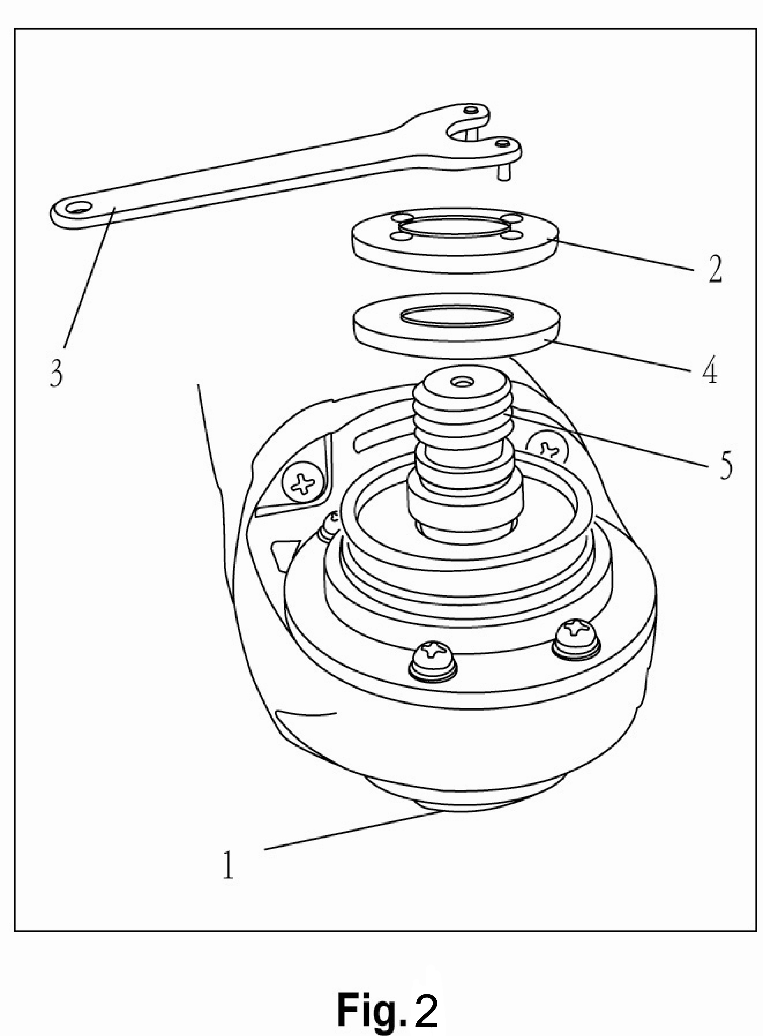
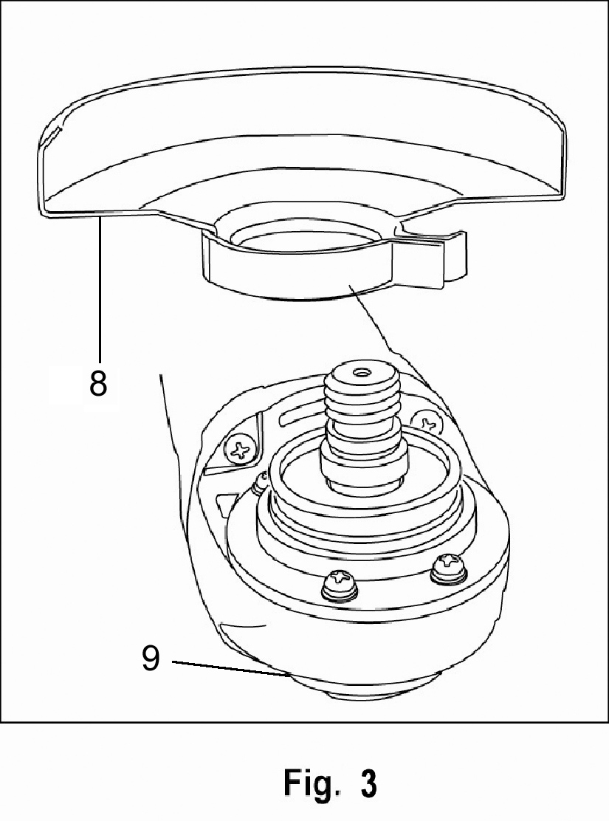
7
9
8

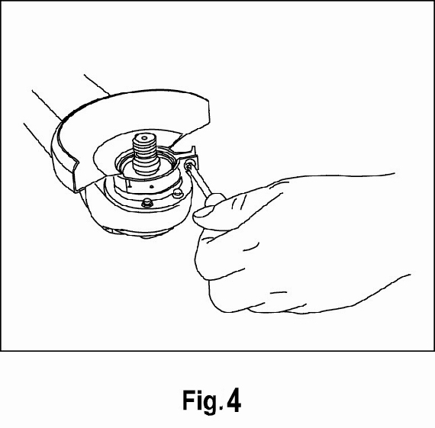
Rotate guard to position it toward the rear of the grinder. Use a #2 Philips® screwdriver to tighten the guard clamp screw (Fig 4). Install the disc flange, making sure it mates with the flats on the spindle. Install the clamp nut finger tight to hold the disc flange in place

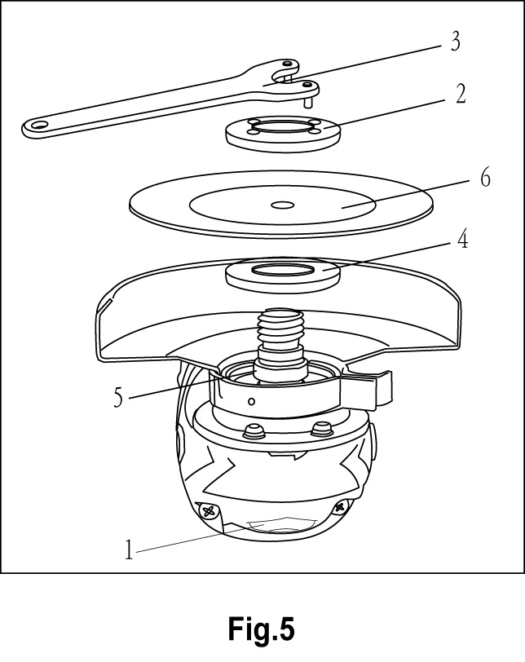
Grinding and Surface Processing
Depress the spindle lock button (1) and rotate the clamp nut (2) until spindle locks (Fig. 5). Turn the clamp nut counter clockwise and remove it from spindle. Make sure the flats on the bottom of disk flange are engaged with the flats on the spindle (5). Place the grinding disc over the spindle with the concave side of the disc (6) facing outward.

ON/OFF switch (Fig.6)
ON: push the switch to “1”
Off: push the switch to “0”
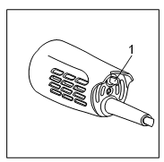

AG950A angle grinder AG950B angle grinder

Overload
The motor of your right angle grinding machine may be damaged when overloaded. This results from excessive working pressure over a prolonged period. Therefore you should not try to accelerate your working speed by increasing pressure on your machine. The abrasive disks work more efficiently if only slight pressure is exerted on the grinding machine, thus avoiding a drop in the grinding speed.

Maintenance

• The protective cover, air slits and motor housing should be kept as free of dirt
and dust as possible.
• Rub off the device with a clean cloth or use compressed air at a low pressure to blow out any dust or dirt. Excessive amounts of metal dust may result in electricity from the internal components being conducted on to exposed metal parts!
• Do not subject the grinding machine to any overload! Overloading will lead to a reduction in the speed and performance and cause the machine to overheat! If this should happen, switch the grinding machine off and let it cool down for approximately 30 minutes or to room temperature!

NOTE: Turning off the grinding machine while it is being subjected to a load will reduce the working life of the operating switch!

Cleaning and Care

• Before cleaning the machine, remove the mains plug from the socket and turn the on and off switch (1) to position (0)!
• For cleaning purposes, only use a slightly damp but not wet cloth!
• Do not use any abrasive additives (petrol, turpentine etc) as these may damage the plastic housing!
• A mild soap is suitable for cleaning the machine!
• Ensure that no moisture is allowed to get inside the machine!
• After cleaning, wipe the machine with a dry cloth!

AG950A angle grinder exploded view
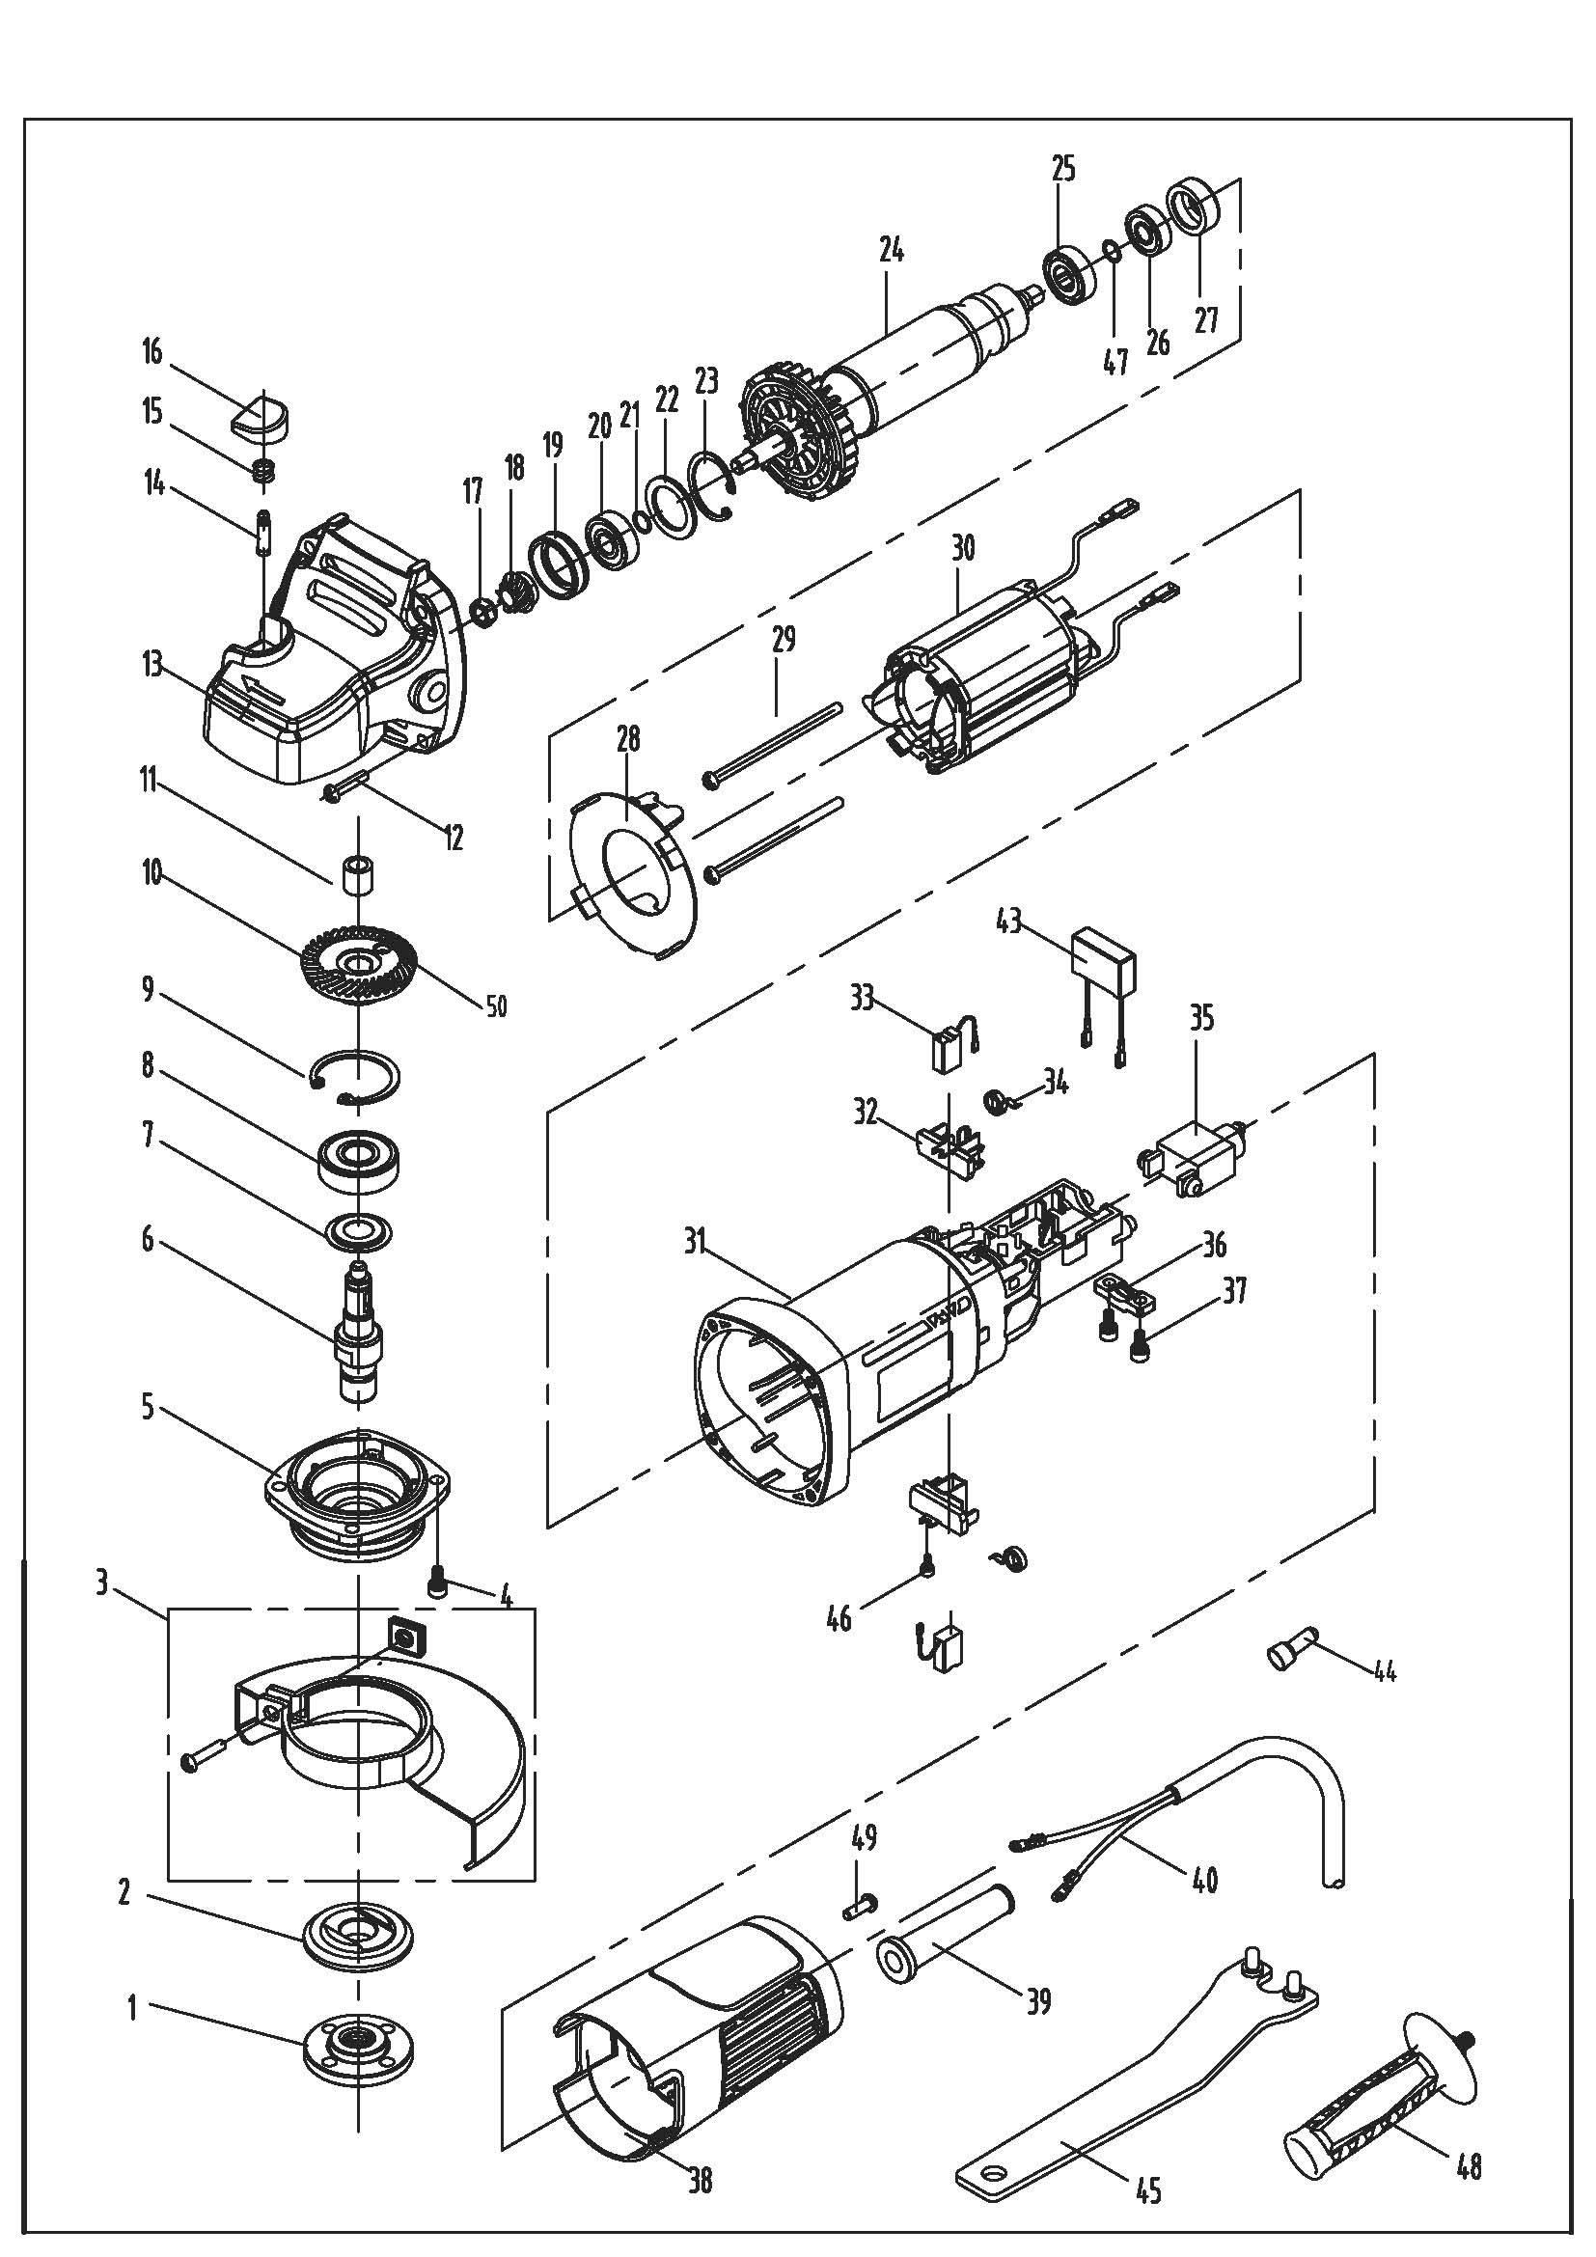

AG950A angle grinder part list
No. | Part list | No. | Part list
1 | Down flange | 26 | Bearing 607Z
2 | Out flange | 27 | bearing bush
3 | Guard | 28 | Wind guide
4 | screw | 29 | Screw
5 | Front cover | 30 | Stator
6 | Spindle | 31 | Housing
7 | Dust cover | 32 | Brush holder
8 | Bearing 6201RS | 33 | Carbon brush
9 | Circlip | 34 | Brush holder spring
10 | Big gear | 35 | Switch
11 | Needle bearing HK0810 | 36 | Cable press board
12 | screw | 37 | screw
13 | Gear box | 38 | Rear cover
14 | Spindle locking pin | 39 | Cable sleeve
15 | Spring | 40 | Cable
16 | Spring locking button | 43 | Capacitor
17 | Nut | 44 | Cable cap
18 | Pinion | 45 | Spanner
19 | Bearing holder | 46 | screw
20 | Bearing 608Z | 47 | Washer
21 | Washer | 48 | Side handle
22 | Bearing press board | 49 | Screw
23 | Circlip
24 | Rotor
25 | Anti-Dust ring

AG950B angle grinder exploded view
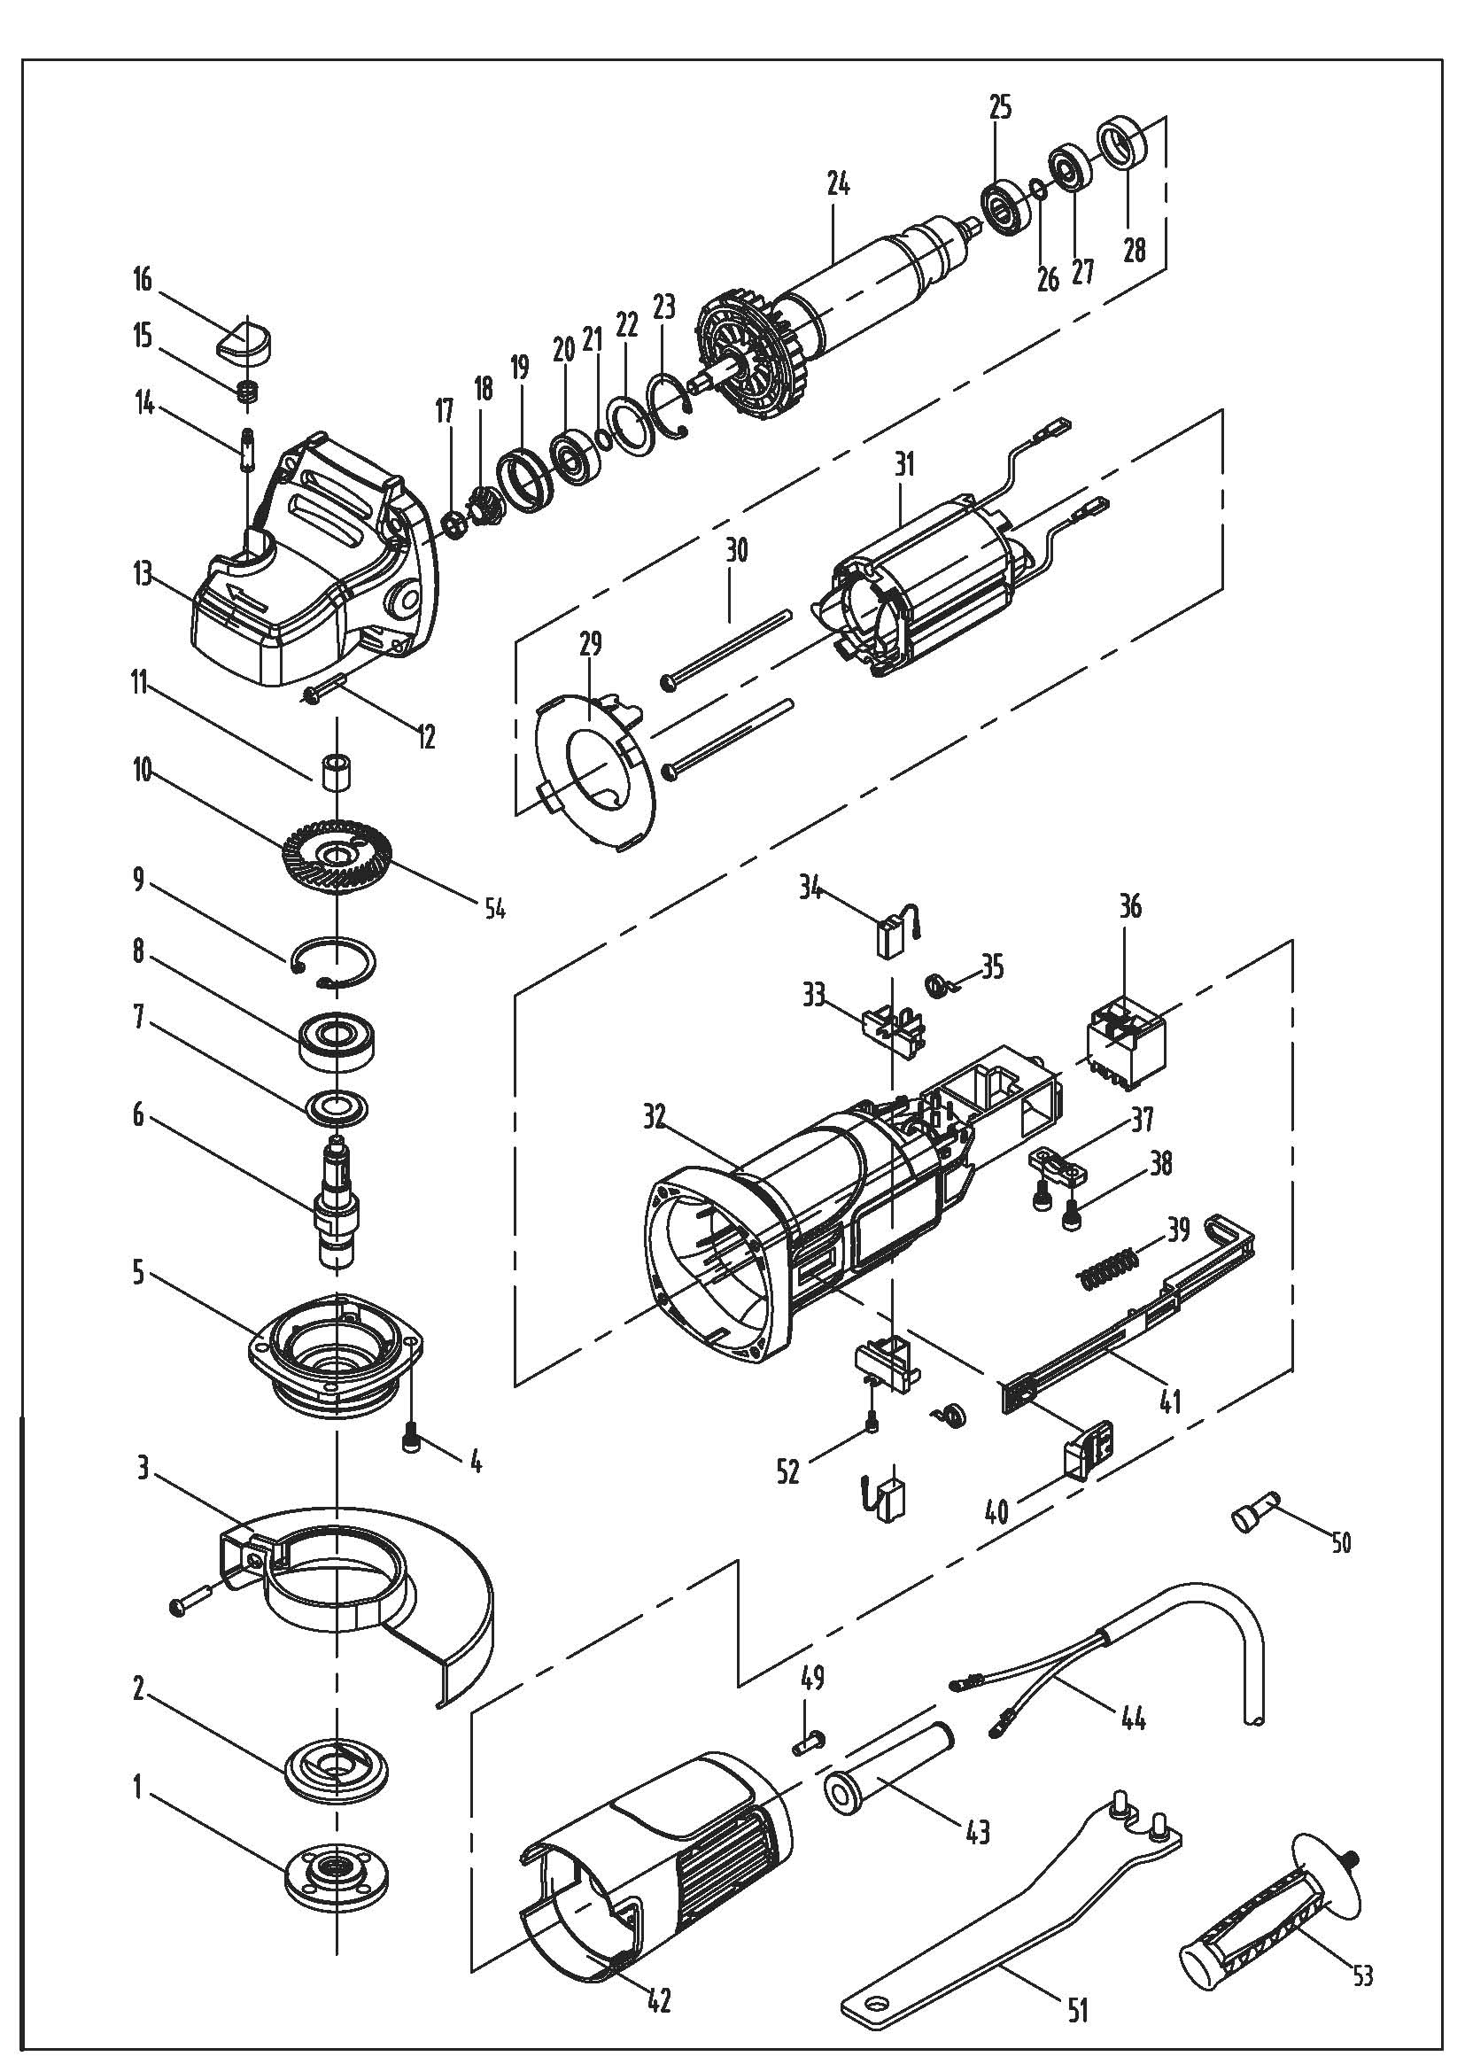

AG950B angle grinder part list
No. | Part list | No. | Part list
1 | Down flange | 26 | Washer
2 | Out flange | 27 | Bearing 607Z
3 | Guard | 28 | Bearing bush
4 | screw | 29 | Wind guide
5 | Front cover | 30 | Screw
6 | Spindle | 31 | Stator
7 | Dust cover | 32 | Housing
8 | Bearing 6201RS | 33 | Brush holder
9 | Circlip | 34 | Carbon brush
10 | Big gear | 35 | Brush holder spring
11 | Needle bearing HK0810 | 36 | Switch
12 | screw | 37 | Cable press board
13 | Gear box | 38 | screw
14 | Spindle locking pin | 39 | Spring
15 | Spring | 40 | Switch trigger
16 | Spring locking button | 41 | Switch push pole
17 | Nut | 42 | Rear cover
18 | Pinion | 43 | Cable sleeve
19 | Bearing holder | 44 | Cable
20 | Bearing 608Z | 49 | screw
21 | Washer | 50 | Cable cap
22 | Bearing press board | 51 | spanner
23 | Circlip | 52 | Screw
24 | Rotor | 53 | Side handle
25 | Anti-Dust ring

