Electric Router
ER710

GB

Read this operators guide carefully, before using the machine. Ensure that you know how the machine works, and how it should be operated. Maintain the machine in accordance with the instructions, and make certain that the machine functions correctly. Keep this operator’s guide and other enclosed documentation with the machine.

TECHNICAL SPECIFICATIONS
Model | ER710
Rated Voltage | 220-240V ~ 50/60Hz
Power | 710w
Chuck size | 6.35/8mm
no load speed | 10000-32000/min
Net weight | 1.8kg

Over view

- Switch
- Variable speed
- Carbon brush cap
- Locking button
- Base move knob

General Safety Instructions for Electric Tools
This device is exclusively for private use! It is not fit for commercial use!
WARNING! Read all instructions. Failure to follow all instructions listed below may result in electric shock, fire and/or serious injury :
SAVE THESE INSTRUCTIONS
1)Work area
• Keep work area clean and well lit. Cluttered and dark areas invite accidents
• Do not operate machines in explosive atmospheres, such as in the presence of flammable liquids, gases or dust. Machines create sparks which may ignite the dust or fumes.
• Keep children and bystanders away while operating a machine. Distractions can cause you to lose control.
2)Electrical safety
• Machine plugs must match the outlet. Never modify the plug in any way. Do not use any adapter plugs with earthed (grounded) machines. Unmodified plugs and matching outlets will reduce risk of electric shock.
• Avoid body contact with earthed or grounded surfaces such as pipes, radiators, ranges and refrigerators. There is an increased risk of electric shock if your body is earthed or grounded.
• Do not expose machines to rain or wet conditions. Water entering a machine will increase the risk of electric shock.
• Do not abuse the cord. Never use the cord for carrying, pulling or unplugging the machine. Keep cord away from heat, oil, sharp edges or moving parts. Damaged or entangled cords increase the risk of electric shock.
• When operating a machine outdoors, use an extension cord suitable for outdoor use. Use of a cord suitable for outdoor use reduces the risk of electric shock.

3)Personal safety
• Stay alert, Watch what you are doing and use common sense when operating a machine. Do not use a machine while you are tired or under the influence of drugs, alcohol or medication. A moment of inattention while operating machines may result in serious personal injury.
• Use safety equipment. Always wear eye protection. Safety equipment such as dust mark, non-skid safety shoes, hard hat, or hearing protection used for appropriate conditions will reduce personal injuries.
•Avoid accidental starting. Ensure the switch is in the off position before plugging in. Carrying machines with your finger on the switch or plugging in machines that have the switch on invites accidents.
•Remove any adjusting key or wrench before turning the machine on. A wrench or a key left attached to a rotating part of the machine may result in personal injury.
•Do not overreach. Keep proper footing and balance at all times. This enables better control of the machine in unexpected situations.
• Dress properly. Do not wear loose clothing or jewellery. Keep your hair, clothing and gloves away from moving parts. Loose clothes, jewellery or long hair can be caught in moving parts.
• If devices are provided for the connection of dust extraction and collection facilities, ensure these are connected and properly used. Use of these devices can reduce dust related hazards.

4)Machine use and care
• Do not force the machine. Use the correct machine for your application. The correct machine will do the job better and safer at the rate for which it was designed.
•Do not use the machine if the switch does not turn it on and off. Any machine that can not be controlled with the switch is dangerous and must be repaired.
•Disconnect the plug from the power source before making any adjustments, changing accessories, or storing machines. Such preventive safety measures reduce the risk of starting the machine accidentally.
• Store idle machines out of the reach children and do not allow persons unfamiliar with the machine or these instructions to operate the machine. Machines are dangerous in the hands of untrained users.
• Maintain machines. Check for misalignment or binding of moving parts, breakage of parts and any other condition that may affect the machines operation. If damaged, have the machine repaired before use. Many accidents are caused by poorly maintained machines.
•Keep cutting tools sharp and clean. Properly maintained cutting tools with sharp cutting edges are less likely to bind and are easier to control.
• Use the machine, accessories and tool bits etc., in accordance with these instructions and in the manner intended for the particular type of machine, taking into account the working conditions and the work to be performed. Use of the machine for operations different from intended could result in a hazardous situation.
5) Service
• Have your machine serviced by a qualified repair person using only identical replacement parts. This will ensure that the safety of the machine is maintained.
OPERATION INSTRUCTIONS
Adjust bit protrusion
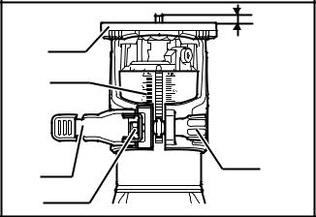
To adjust the bit protrusion, loosen the locking lever and move the tool base up or down as desired by turning the adjusting screw. After adjusting, tighten the locking lever firmly to secure the tool base.
1 1.bit protrusion
2 2.tool base
3 3. scale
4. locking lever
5. adjusting screw
6. hex nut
4 5
6
Switch action
To start the tool, press the “ON (I) ”side of the switch.
To stop the tool, press the “OFF(0)” side of the switch.
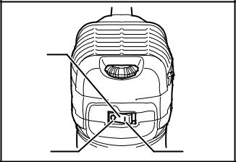
1.Switch
2.OFF(O) side
1 3.ON(I) side

2 3
Speed adjusting dial
The tool speed can be changed by turning the speed adjusting dial to given number setting from 1 to 6. Higher speed is obtained when the dial is turned in the direction of number 6. And lower speed is obtained when it is turned in the direction of number 1. This allows the ideal speed to be selected for optimum material processing, the speed can be correctly adjusted to suit the material and bit diameter. Refer to the table for the relationship between the number settings on the dial and the approximate tool speed.
Number | MIN⁻¹
1 | 10000
2 | 12000
3 | 17000
4 | 22000
5 | 27000
6 | 32000

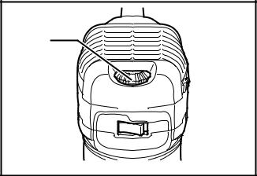
1. Speed adjusting dial
1

Installing or removing trimmer bit
Insert the bit all the way into the collect cone and tighten the collect nut security with the two wrenches or by pressing the shaft lock and using the provide wrench. To remove the bit, follow the installation procedure in reverse.
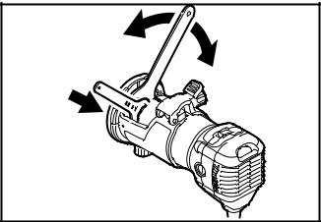
1 1.tighen
2 2.loosen
3 3.hold

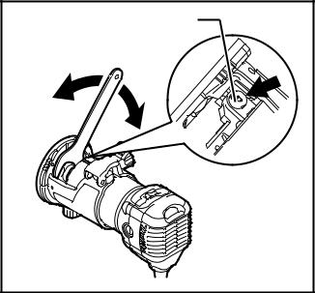
3 1. Tighten
2. loosen
1 2 3. Shaft lock

Operation with straight guide
The straight guide is effectively used for straight cuts when chamfering or grooving. Attach the guide plate to the straight guide with the bolt and the wing nut. Attach the straight guide with the clamp screw (A). Loosen the wing nut on the straight guide and adjust the distance between the bit and the straight guide. At the desired distance, tighten the wing nut securely.
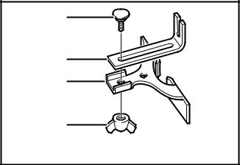
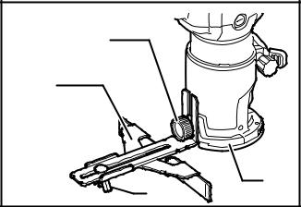
1 1.bolt 1 1. Clamp screw (A)
2 2.guide plate 2 2.straight guide
3 3.straight guide 3. Wing nut
4 4.wing nut 4 4. Base
3
Circular work
Circular work may be accomplished if you assemble the straight guide and guide plate as shown in the figures. Min and Max radius of circles to be cut (distance between the center of circle and the center of bit) are as follow:
Min: 70mm(2-3/4”)
Max: 221mm (8-11/16”)

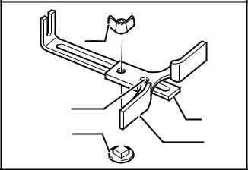
1 1.wing nut
2.guide plate
3.straight guide
4 2 4. Center holder
5 3 5. Bolt

Trimmer guide
Trimming, curved cuts in veneers for furniture and the like can be done easily with the trimmer guide. The guide roller rides the curve and assures a fine cut. Install the trimmer guide on the tool base with the clamp screw (A). Loosen the clamp screw(B) and adjust the distance between the bit and the trimmer guide by turning the adjusting screw. At the desired distance, tighten the clamp screw(B) to secure the trimmer guide in place. When cutting, move the tool with the guide roller riding the side of the workpiece.
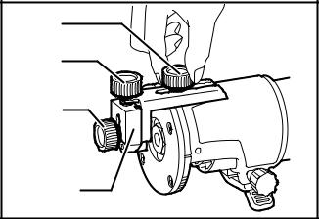
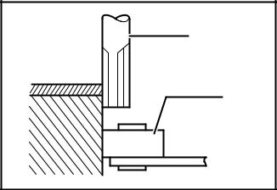
1 1. Clamp screw(A) 2 1. workpiece
2 2. Adjusting screw 2 .bit
3. clamp screw (B) 3 3. Guide roller
3 4.trimmer guide 1

4

Overload
The motor of your electric router may be damaged when overloaded. This results from excessive working pressure over a prolonged period. Therefore you should not try to accelerate your working speed by increasing pressure on your machine.
Replacing carbon brush
Remove and check the carbon brusher regularly. Replace when they wear down to limited mark. Keep the carbon brushes clean and free to slip in the holders. Both carbon brushes should be replaced at the same time. Use only identical carbon brushes.
Use a screwdriver to remove the brush holder caps. Take out the worn carbon brushes, insert the new ones and secure the brush holder caps. To maintain product SAFETY and RELIABILITY, repairs, any other maintenance or adjustment should be performed by authorized service centers, always using replacement parts.
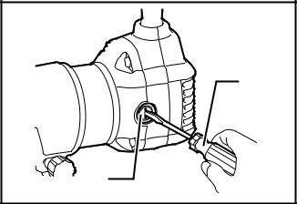
1.screwdriver
2.brush holder cap
1

2

ER710 exploded view

ER710 Part list

