Spray gun
SG130
EN

EN

Read this operators guide carefully, before using the machine. Ensure that you know how the machine works, and how it should be operated. Maintain the machine in accordance with the instructions, and make certain that the machine functions correctly. Keep this operator’s guide and other enclosed documentation with the machine.

- TECHNICAL SPECIFICATIONS
Model | SG130
Rated Voltage | 220-240V ~ 50/60Hz
Power | 130W
Nozzle | Φ0.8mm
Max. Flow | 320/min
Container capacity | 800ml
Max consistency | 60din/sec
Vibration emission | 11.53m/s²
Sound pressure level | 91dB(A)
Sound power level | 102dB(A)
Net weight | 1.5kg

Check the machine, loose parts and accessories for transport damage.
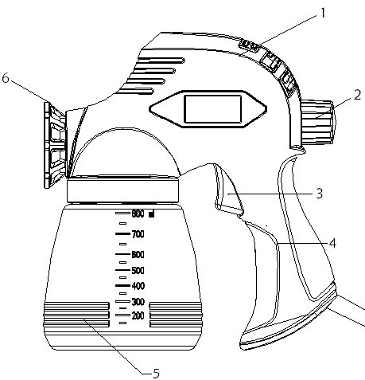
Product information:
Fig. A.

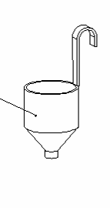
1. Motor housing
2. Output control
11
10
9
3. Trigger switch
4. Handle
7
8
5. Paint container
6. Spray basket nozzle
7. Viscosity cup
8.needle
9. wrench
Fig A
10. nozzle
11. Spare valve

- SAFETY INSTRUCTIONS

The following symbols are used in these instructions for use:
 | Denotes risk of personal injury, loss of life or damage to the tool in case of nonobservance of the instructions in this manual.
 | Denotes risk of electric shock.
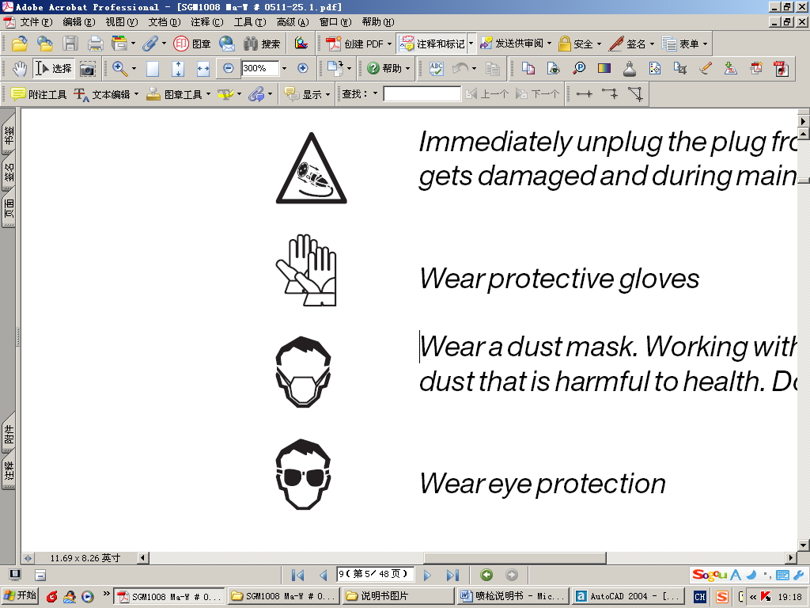 | Wear protective gloves
Wear a dust mask. Working with wood, metals and other materials may produce
dust that is harmful to health. Do not work with material containing asbestos!
 | Wear eye protection
Warning!
Read all instructions. Failure to follow all instructions listed below may result in electric shock, fire and/or serious injury. The term “power tool” in all of the warnings listed below refers to your mains operated (corded) power tool or battery operated (cordless) power tool. Save these instructions.
1) Work area
a. Keep work area clean and well lit. Cluttered and dark areas invite accidents.
b. Do not operate power tools in explosive atmospheres, such as in the presence of flammable liquids, gasses or dust. Power tools create sparks which may ignite the dust of fumes.
c. Keep children and bystanders away while operating a power tool. Distractions can cause you to lose control.
2) Electrical safety
a. Power tool plugs must match the outlet. Never modify the plug in any way. Do not use any
adapter plugs which earthed (grounded) power tools. Unmodified plugs and matching outlets will reduce risk of electric shock.
b. Avoid body contact with earthed or grounded surfaces such as pipes, radiators, ranges and
refrigerators. There is an increased risk of electric shock if your body is earthed or grounded.
c. Do not expose power tools to rain or wet conditions. Water entering a power tool will increase the risk of electric shock.
d. Do not abuse the cord. Never use the cord for carrying, pulling or unplugging the power tool.
Keep cord away from heat, oil, sharp edges or moving parts. Damaged or entangled cords
increase the risk of electric shock.
e. When operating a power tool outdoors, use an extension cord suitable for outdoor use. Use of a cord suitable for outdoor use reduces the risk of electric shock. Always use tool in conjunction with a residual circuit breaker device.
3) Personal safety
a. Stay alert, watch what you are doing and use common sense when operating a power tool.
Do not use a power tool while you are tired or under the influence of drugs, alcohol or medication.
A moment of inattention while operating power tools may result in serious personal injury.
b. Use safety equipment. Always wear eye protection. Safety equipment such as dust mask, non-skid safety shoes, hard hat, or hearing protection used for appropriate conditions will reduce personal injuries.
c. Avoid accidental starting. Ensure the switch is in the off position before plugging in. Carrying
power tools with your finger on the switch or plugging in power tools that have the switch on invites accidents.
d. Remove any adjusting key or wrench before turning the power tool on. A wrench or a key
left attached to a rotating part of the power tool may result in personal injury.
e. Do not overreach. Keep proper footing and balance at all times. This enables better control
of the power tool in unexpected situations.
f. Dress properly. Do not wear loose clothing or jewellery. Keep your hair, clothing and gloves
away from moving parts. Loose clothes, jewellery or long hair can be caught in moving parts.
g. If devices are provided for the connection of dust extraction and collection facilities, ensure
these are connected and properly used. Use of these devices can reduce dust related hazards.
h. Use clamps or a vice to hold work. It’s safer than using your hand and it frees both hands
to operate tool.
4) Power tool use and care
a. Do not force the power tool. Use the correct power tool for your application. The correct
power tool will do the job better and safer at the rate for which it was designed.
b. Do not use the power tool if the switch does not turn it on and off. Any power tool that
cannot be controlled with the switch is dangerous and must be repaired.
c. Disconnect the plug from the power source before making any adjustments, changing
accessories, or storing power tools. Such preventive safety measures reduce the risk of starting the power tool accidentally.
d. Store idle power tools out of the reach of children and do not allow persons unfamiliar
with the power tool or these instructions to operate the power tool. Power tools are dangerous in the hands of untrained users.
e. Maintain power tools. Check for misalignment or binding of moving parts, breakage of parts
and any other condition that may affect the power tools operation.
If damaged, have the power tool repaired before use. Many accidents are caused by poorly maintained power tools.
f. Keep cutting tools sharp and clean. Properly maintained cutting tools with sharp cutting edges are less likely to bind and are easier to control.
g. Use the power tool, accessories and tool bits etc., in accordance with these instructions and
in the manner intended for the particular type of power tool, taking into account the working
conditions and the work to be performed. Use of the power tool for operations different from intended could result in hazardous situation.
h. Damaged switches must be replaced at a customer service repair centre. Do not use power
tools that cannot be switched on and off.
i. Do not leave power tools unattended while they are switched on. Always switch off the
tool and wait until it has come to a full standstill before leaving.
j. If the mains cable has been damaged, it must be replaced with a special mains cable. These
can be obtained from the manufacturer or the manufacturer's customer service department. The mains cable may only be replaced by the manufacturer, the manufacturer's customer service department or equally qualified persons.
5) Service
a. Please use a qualified expert who uses original replacement parts to repair your power tool. This will ensure proper functioning of the power tool.
b. Caution! The use of any accessories or additional tools other than those recommended in this manual may lead to an increased risk of injury. Only use original replacement parts.

Additional safety instructions

• NEVER SPRAY AT PERSONS - Never aim the nozzle at another person or animal. Never
allow the spray to come into direct contact with the skin.
• FLASH POINT - This spray gun must not be used for spraying flammable paints and solvents with a flash point of less than 32 °C
• VENTILATION - Always make sure that there is adequate ventilation in the work area when
spraying.
• BASKET NOZZLE -Always keep the spray basket nozzle in place during use.
• CONSIDER WORK AREA ENVIRONMENT -Do not use spray guns where there is a risk of
fire or explosion.
• BEWARE OF ANY HAZARD -Beware of any Hazard by the material being sprayed and consult the markings on the container or the information supplied by the manufacturer.
• DO NOT SPRAY - Do not spray any material where the hazard is not known.
• USE EYE PROTECTION - Always use appropriate eye protection to keep hazardous vapors or fumes out of the eyes.
• WEAR A MASK - Never operate a spray gun without wearing a face mask.
• PROTECT YOUR EARS -Wear ear protectors if the sound pressure exceeds 85 dB(A).
• MAINTAIN YOUR TOOLS - Keep your spray gun, paint container and nozzles clean. Do not clean with flammable liquids with a flash point less than 32 °C Inspect the mains lead periodically and if damaged have it replaced by a qualified person.
• NAKED FLAMES -Never spray near a naked flame or appliance pilot flame.
• SMOKING -Never smoke whilst spraying.
• THINNING - Always read the paint manufacturers thinning recommendations or instructions before using paint or other materials.
• DISCONNECT FROM THE MAINS SUPPLY - Always disconnect from the mains supply when filling the paint container or cleaning the spray gun.
• SWITCH OFF WHEN NOT SPRAYING -Avoid running the unit with the flow rate knob fully closed for any length of time.
Immediately switch off the spray gun when:
• Interruption in the mains plug, mains lead or mains lead damage.
• Defect switch.
• Smoke or stench of scorched isolation.

Electrical safety
Warning! When using electric tools, basic safety precautions should always be followed to
reduce the risk of fire, electric shock and personal injury. Read all these instructions before
attempting to operate this product and save these instructions.
Always check that the mains voltage corresponds to the voltage on the rating plate.
The machine is double insulated in accordance with EN50144; therefore no earth
wire is required.

Replacing cables or plugs
Immediately throw away old cables or plugs when they have been replaced by new ones. It is
dangerous to insert the plug of a loose cable in the wall outlet.
Using extension cables
Only use an approved extension cable suitable for the power input of the machine. The
minimum conductor size is 1.5 mm². When using a cable reel always unwind the reel
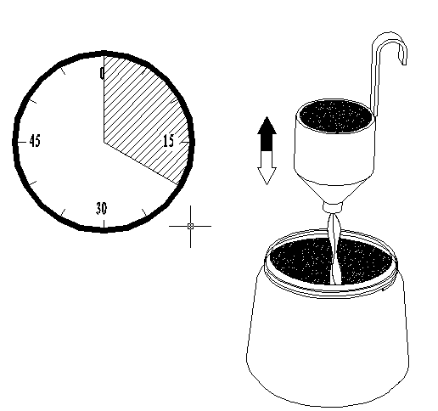
completely.

3. OPERATION INSTRUCTIONS

Preparation
Fig. B

Fig. B
Do not use textured wall paints or coatings as this will block the nozzle.
To obtain the best results, it is important that you prepare the surface to be sprayed and thin the paint to the correct viscosity, before you operate your spray gun. Always ensure that the surfaces to be sprayed are free from dust, dirt and grease. Make sure that you have masked the areas that should not be sprayed, using a good quality masking tape. The paint or fluid to be sprayed should be thoroughly mixed and free from lumps or other particles. Many substances can be sprayed with your spray gun, but always check the manufacturers recommendations before purchasing your paint.
Thinning
Always remember to disconnect from the mains supply before filling the paint container with spray able material.
Most paints are supplied ready for brush application and will need to be thinned before they are suitable to be sprayed. Follow the manufacturer’s advice on thinning the paint when used with a spray gun. The viscosity cup will help you to determine the correct viscosity of paint to be used. To determine the correct viscosity, fill the cup to the brim with the paint. Measure the amount of time it takes for the cup to empty back into the can. The table below shows recommended times for different types of material.
Plastic & latex paint | 24 - 28 seconds
Water based paint | 20 - 25 seconds
Primers | 24 - 28 seconds
Varnishes | 20 - 25 seconds
Oil based paints | 18 - 22 seconds
Enamel paints | 18 - 22 seconds
Aluminum paints | 22 - 25 seconds
Car undersealing | 25 - 35 seconds
Wood sealers | 28 - 35 seconds
Wood preservatives | No thinning required
Wood stains | No thinning required

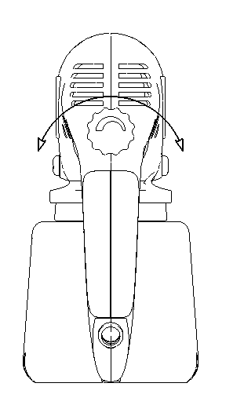
If the paint takes longer than the recommended time to empty, then further thinning is required. Mix in a small quantity of the appropriate thinner and use the viscosity test until the correct thickness is achieved. Some spray able materials contain particles and lumps. These materials should be strained before filling the paint container.

Spraying
Fig. C
Fill the paint container with the correctly thinned and strained paint. Connect the spray gun to the mains supply. Aim the spray gun at a piece of scrap material and operate the trigger switch until paint is spraying. Adjust the output control (2) until the required volume of paint is spraying. Turn the output control in a clockwise direction (B) to reduce the flow and anti-clockwise (A) to increase the flow. Adjustment of the output control will affect the spray pattern. A poor spray pattern will concentrate the paint in the centre of the spray and give a blotchy finish. A good spray pattern will give even distribution of paint throughout the pattern.
Fig. C

Spraying techniques
Fig. D Fig. E
To obtain the best results, keep your spray gun level and parallel to the surface at all times. Keep the nozzle 25 - 30 cm from the surface and spray evenly from side to side or up and down. Do not spray at an angle as this will lead to paint runs on the surface. Use smooth and even strokes. When spraying large areas, using a criss-cross pattern as shown.

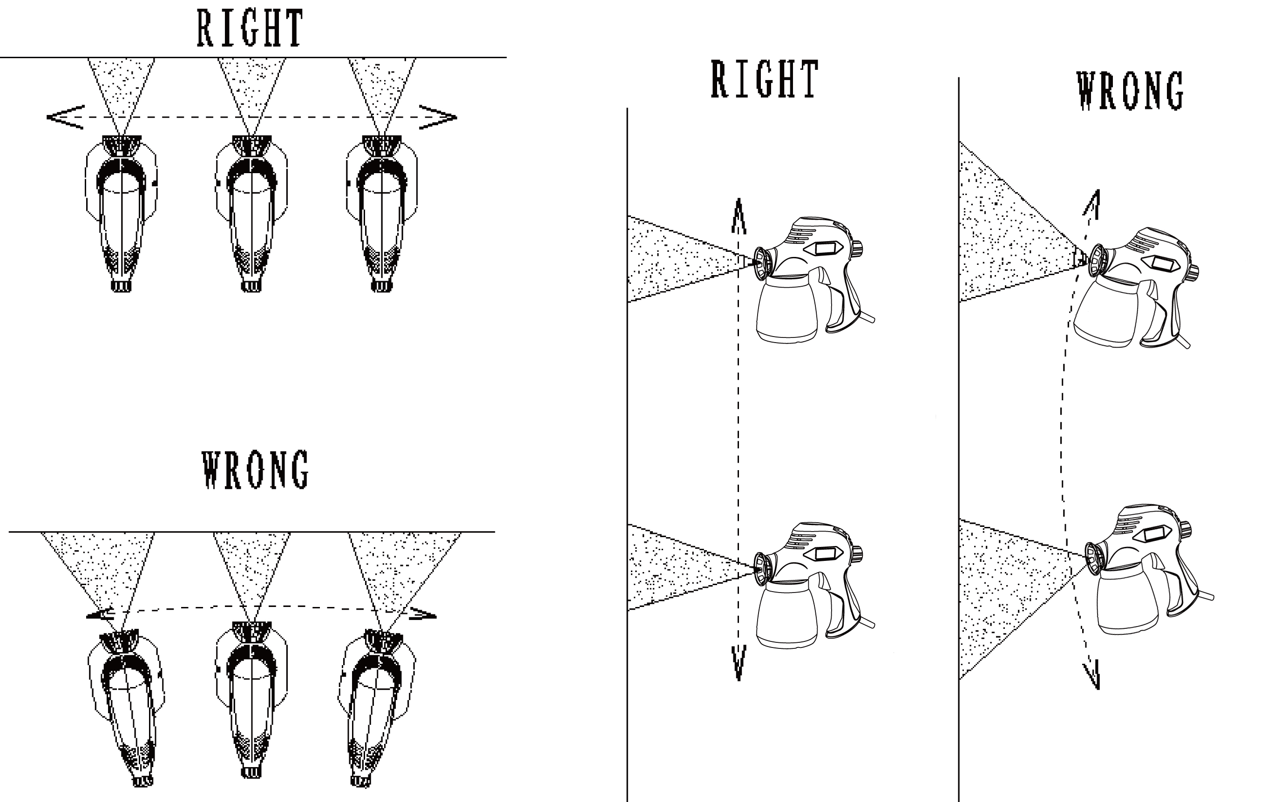
Fig. D

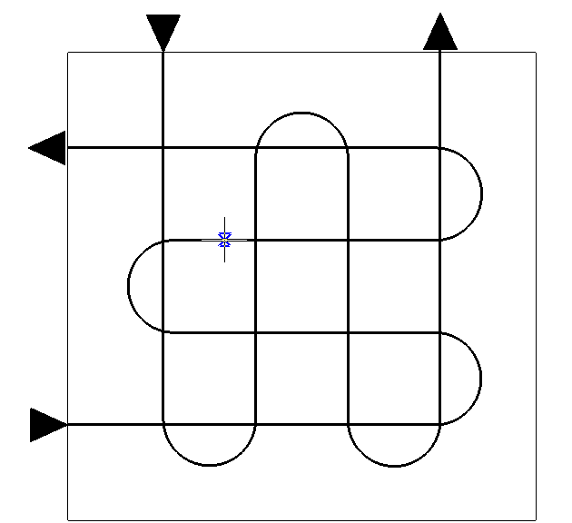
Never start or stop the spray gun while it is aimed at the surface to be sprayed. Evenly control the speed of movement of the spray gun. A fast speed of movement over the surface will give a thin coat and a slow speed will give a heavy coat. Apply one coat at a time. If a further coat is required, make sure you observe the manufacturers drying time recommendations before applying a second coat. When spraying small areas, keep the output control on a low setting. This will avoid using too much paint and prevent overspray.
Fig. E
Where possible, avoid stopping and starting when spraying an object. This can lead to too much, or not enough paint being applied. Do not tip the spray gun to more than 45°.

Fitting and using the flexible nozzle
Fig. F
The flexible nozzle extension should be used to spray flat or horizontal surfaces. It should also
be used in areas with limited access.
To fit the flexible nozzle, unscrew the basket nozzle and attach the flexible nozzle in its place.
Replace the basket nozzle on the end of the flexible nozzle and tighten.

Fig. F

4. MAINTENANCE
Make sure that the plug is removed from the mains when carrying out maintenance work on the motor.
The machines have been designed to operate over a long period of time with a minimum of maintenance. Continuous satisfactory operation depends upon proper machine care and regular cleaning.
Troubleshooting
Motor hums but does not spray or irregular spraying. | - Worn swirl head  - Pick up pipe not in the right position  - Blocked pick up pipe  - Blocked nozzle  - Blocked filter  - Control knob needs adjustment | - Replace swirl head.  - Re-adjust pick up pipe.  - Clean with thinner.  - Clean nozzle.  - Clean with thinner.  - Adjust.
Atomization is not good. | - Volume adjustment is not correct.  - Paint too thick | - Adjust.  - Check viscosity of the paint.
Over painting. | - Spray gun not clean, or not lubricated resulting in piston being stuck in cylinder  - Too much paint  - Viscosity too low | - Disassemble spray gun and  , clean with thinner.  - Adjust the volume clockwise to reduce spraying. Two thin  coats are better then one  - Check viscosity
Motor louder than normal. | - Spray gun not clean, or not lubricated, resulting in piston being stuck in cylinder | - Disassemble spray gun and clean with thinner.
No spray, no sound. | - No electricity | - Check power supply
Operating sound not right. | - Poor output adjustment  - Not enough paint in the container resulting in air being sucked in.  - Not diluting properly or not passing pick up pipe completely. | - Re-adjust  - Refill with paint.  - Check pick up pipe and viscosity level.
“Orange Skin” excessive fogging. | - Incorrect solvent is used  - Spray gun too far from the surface.  - Paint too thick | - Use correct solvent.  - Hold spray gun closer to the object.  - Thin the paint

Cleaning and maintenance
Fig.G
Always remember to disconnect from the mains supply before cleaning the spray gun or paint container.
It is essential that the spray gun is cleaned thoroughly after every use. Failure to clean it will almost certainly result in blockages and it may not operate when you next come to use it! The guarantee does not cover cleaning a sprayer that has not been properly cleaned by the user.
The following action must be taken after every use:
1. Empty any remaining material from the container.
2. Clean the container thoroughly with the thinner that was used.
3. Pour some thinner into the container and spray through the spray gun until only clean thinner is coming out of the nozzle.
4. Thoroughly clean the paint pick up pipe and filter with thinner.
5. Clean the basket and nozzle and remove any other debris or paint that remains.
6. Turn the spray gun upside down and apply a few drops of light lubricating oil to the
two apertures (D).
This will lubricate the piston and cylinder.
If your spray gun should require extra internal cleaning, it may be necessary to disassemble it.
If so the following action should be taken:
1. Remove the plug from the mains socket.
2. Remove paint container, pick up pipe and filter（C）.
3. Release the nozzle (B), valve (A).
4. Clean the cylinder and all parts thoroughly with solvent.
5. Apply a few drops of light lubricating oil to the piston, spring and cylinder.
6. Reassemble the spray gun.

B
A
C

D

Fig.G

Faults
Should a fault occur, e.g. after wear of a part, please contact the service address on the warranty card. In the back of this manual you find an exploded view showing the parts that can be ordered.
Meaning of crossed –out wheeled dustbin:
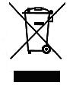
Do not dispose of electrical appliances as unsorted municipal waste, use separate collection facilities.
Contact you local government for information regarding the collection systems available.
If electrical appliances are disposed of in landfills or dumps, hazardous substances can leak into the groundwater and get into the food chain, damaging your health and well-being.
When replacing old appliances with new ones, the retailer is legally obligated to take back your old appliance for disposals at least free of charge.

